**Algorithm Specification Sheet - Alinity IA Optics Dark Count**

**References**

APLM ID D000039774/A

**Summary**

To implement a Predictive Health Notification (PHN) for Alinity-i Analyzers that will detect degrading Background Read performance before the customer begins experiencing an increase in Error: 1401 Unable to process test, background read failure.

|  |  |
| --- | --- |
| PHN Descriptor | Alinity IA Optics Dark Count |
| PHN Experience Code / Name | CCA1 PHN_Alinity_IA; PHN_Optics_IA; Dark Counts |
| PHN KM Article Number/ Name | K07342335 PHN_Alinity IA: Optics Dark Count  <https://addkm.abbott.com/advisor/showcase?case=K07342335&project=Abbott> |
| Service Level | FSE 2 |
| Always On Package | Always On 01DP5- 01, 02, 03, 09, 80, 83, 84, 89 |
| IDA Table | IDAQOWNER.ICQ_RESULTS |
| IDA Table Fields | MODULESN, INTEGRATEDDARKCOUNT, TESTID, LODGATE_LOCAL |
| Analysis Frequency | Daily |
| Data Required | Previous 1 day |
| Data Aggregation | None |
| Run Time Estimate | 7 seconds (1 day, 20 instruments, 7,732 rows, 2 algorithm flags) |
| Flag Criteria | N unique TESTIDs >= 10 and  INTEGRATEDDARKCOUNT Maximum >= 543 and  INTEGRATEDDARKCOUNT Standard Deviation >= 110 |
| Probable Failure Modes | Salt buildup in the process path from leaking wash zones or trigger manifold.  Light leakage due to loose covers, diverters or shutter movement problems. |
| Suppression Experience Codes | Z1OP, Z1OR, FAAA, FAAB, FAA1, FAC1 |
| Applicable Work Done Codes (WDC) | FA3*: Optics CMIA Background/ Stray light  FAG*: Optics CMIA Debris/dirty  FB3*: Optics Reader Shutter Background  FBG*: Optics Reader Shutter Dirty |

**Data Processing Steps**

|  |  |
| --- | --- |
| Data Processing Steps | |
| 1 | Query all data from the previous day for each instrument (IDA Table: IDAQOWNER.ICQ_RESULTS). |
| 2 | Exclude tests where INTEGRATEDDARKCOUNT is missing. |
| 3 | Exclude instruments where the number of unique TESTIDs is less than 10. |
| 4 | Summarize the data by calculating the INTEGRATEDDARKCOUNT maximum and standard deviation by instrument. |
| 5 | Flag any instrument where the number of unique TESTIDs is greater than or equal to 10, and the INTEGRATEDDARK COUNT maximum is greater than or equal to 543, and the INTEGRATEDDARKCOUNT standard deviation is greater than or equal to 110. |

**APPENDIX 1:** CCA1 AI Dark Count

**Algorithm Code**

SELECT

evals.MODULESN

FROM

(SELECT

R.MODULESN,

MAX(R.INTEGRATEDDARKCOUNT) AS MAX_IDC,

STDDEV(R.INTEGRATEDDARKCOUNT) AS SD_IDC,

COUNT(DISTINCT(R.TESTID)) AS NUM_TESTID

FROM

IDAQOWNER.ICQ_RESULTS R

WHERE

R.LOGDATE_LOCAL >= TRUNC(SYSDATE) - 1

AND R.LOGDATE_LOCAL < TRUNC(SYSDATE)

AND R.INTEGRATEDDARKCOUNT IS NOT NULL

GROUP BY

R.MODULESN

ORDER BY

R.MODULESN

) evals

WHERE

evals.MAX_IDC >= 543

AND evals.SD_IDC >= 110

AND evals.NUM_TESTID >= 10

**Apollo Algorithm Details**

(* is Mandatory)

|  |  |
| --- | --- |
| **Apollo Details** |  |
| Algorithm ID * | AlinityIA_DarkCount |
| Algorithm Name * | AI Dark Count |
| Algorithm Description * | To detect degrading Background Read performance before the customer begins experiencing an increase in Error: 1401 Unable to process test, background read failure. |
| Product Family * | Alinity IA |
| Algorithm Group * | Alinity Optics |
| Functional Area | N/A |
| Algorithm Category 1 | N/A |
| Algorithm Category 2 | N/A |
| Algorithm Category 3 | N/A |
| Remaining Useful Life Value | 3 |
| Remaining Useful Life Unit | Day |
| Keep Results Num Days | 14 |
| **Routine Details** |  |
| Routine Source | Define New Routine |
| Reusable Routines | No |
| Routine Type | Oracle Procedure |
| Run Mode | Batch |
| Routine Invoke Command | PHM_ICQ_DarkCount_PROC |
| Routine Procedure (SQL file) | PHM_ICQ_DarkCount_PROC |
| Status | Enable |
| Repeat Deploy | N/A |
| **ODS Routine Details** |  |
| ODS Routine Name | PHM_ODS_ICQ_RESULTS_PROC |
| **Predictive Health Notification Details** |  |
| PHN Code | CCA1 |
| PHN Level 1 Description | PHN_Alinity_IA |
| PHN Level 2 Description | PHN_ Optics_IA |
| PHN Level 3 Description | Dark Count |
| **Knowledge Management DB Articles** |  |
| KM Article ID | K07342335 |
| KM Article | PHN_Alinity IA: Optics Dark Count |
| KM Link | <https://addkm.abbott.com/advisor/showcase?case=K07342335&project=Abbott> |
| **Parameters** |  |
| Parameter Group Name | INTEGRATEDDARKCOUNT_ |
| Parameter Name | INTEGRATEDDARKCOUNT_UNIQUETESTID  INTEGRATEDDARKCOUNT_MAX, INTEGRATEDDARKCOUNT_SD |
| Parameter Values | 10, 543, 110 |
| **Chart Details** |  |
| Chart Title | ICQ Dark Count |
| Chart Type | Line |
| Chart Threshold Parameter | Threshold_Count |
| Group ID | Group 7 |
| Chart X Axis Name | Date |
| Chart Y Axis Name | Threshold |

**APPENDIX 2:** Algorithm Understanding Check – Algorithm Developer to Predictive Health Monitoring (PHM) Specialist Transition

**Data Set Description**

The data set for this understanding check was retrieved from the ICQOWNER.ICQ_RESULTS table within the BSQD1I database. Data was collected for all instruments between December, 1 2016 and February 28, 2017, inclusive. Data collection was limited to the SERIALNUMBER, DATETIMESTAMP, INTEGRATEDDARKCOUNT, and TESTID fields.

**Data Set Retrieval**

The following SQL code was used to retrieve the data set:

SELECT

R.SERIALNUMBER,

R.DATETIMESTAMP,

R.INTEGRATEDDARKCOUNT,

R.TESTID

FROM

ICQOWNER.ODR_RESULTSICQ R

WHERE

TRUNC(R.DATETIMESTAMP) >= TO_DATE('12/01/2016 12:00:00 AM', 'mm/dd/yyyy hh:mi:ss am')

AND TRUNC(R.DATETIMESTAMP) < TO_DATE('03/01/2017 12:00:00 AM', 'mm/dd/yyyy hh:mi:ss am')

**Algorithm Developer Analysis**

The following JMP script (JMP version 12.1.0) was used by the Algorithm Developer to analyze the data set and flag algorithm violations:

New SQL Query**(**

Connection**(**

"ODBC:DSN=BSQD1I;UID=birchkm;PWD=%_PWD_%;DBQ=BSQD1I;DBA=W;APA=T;EXC=F;FEN=T;QTO=T;FRC=10;FDL=10;LOB=T;RST=T;BTD=F;BNF=F;BAM=IfAllSuccessful;NUM=NLS;DPM=F;MTS=T;MDI=F;CSR=F;FWC=F;FBS=100000000;TLO=O;MLD=0;ODA=F;"

**)**,

QueryName**(** "ODR_RESULTSICQ" **)**,

Select**(**

Column**(** "MODULESNDRM", "t2" **)**,

Column**(** "SERIALNUMBER", "t2" **)**,

Column**(** "TESTID", "t2" **)**,

Column**(**

"DATETIMESTAMP",

"t2",

Numeric Format**(** "m/d/y h:m:s", "0", "NO", "" **)**

**)**,

Column**(** "INTEGRATEDDARKCOUNT", "t2" **)**

**)**,

From**(** Table**(** "ODR_RESULTSICQ", Schema**(** "ICQOWNER" **)**, Alias**(** "t2" **)** **)** **)**,

Where**(**

Is Not Null**(**

Column**(** "INTEGRATEDDARKCOUNT", "t2" **)**,

UI**(** NullTest**(** Base**(** "Continuous" **)** **)** **)**

**)** & GE**(**

Column**(**

"DATETIMESTAMP",

"t2",

Numeric Format**(** "m/d/y h:m:s", "0", "NO", "" **)**

**)**,

**3563395200**,

UI**(** Comparison**(** Base**(** "Continuous" **)** **)** **)**

**)** & LT**(**

Column**(**

"DATETIMESTAMP",

"t2",

Numeric Format**(** "m/d/y h:m:s", "0", "NO", "" **)**

**)**,

**3571171200**,

UI**(** Comparison**(** Base**(** "Continuous" **)** **)** **)**

**)**

**)**

**)** << **Run**

Data Table**(** "ODR_RESULTSICQ" **)** << **Summary(**

Group**(** :MODULESNDRM, :SERIALNUMBER, :Day **)**,

N**(** :TESTID **)**,

Max**(** :INTEGRATEDDARKCOUNT **)**,

Std Dev**(** :INTEGRATEDDARKCOUNT **)**,

Freq**(** "None" **)**,

Weight**(** "None" **)**

**);**

New Column**(** "Flag Yes/No",

Numeric,

"Nominal",

Format**(** "Best", **12** **)**,

Formula**(**

If**(**

:Name**(** "N(TESTID)" **)** >= **10** & :Name**(** "Max(INTEGRATEDDARKCOUNT)" **)** >= **543** &

:Name**(** "Std Dev(INTEGRATEDDARKCOUNT)" **)** >= **110**,

**1**,

**0**

**)**

**)**,

Value Labels**(** **{0** = "No", **1** = "Yes"**}** **)**,

Use Value Labels**(** **1** **)**

**);**

**PHM Specialist Analysis**

The following SQL code was used by the PHM Specialist to analyze the data set and flag algorithm violations:

SELECT

evals.SERIALNUMBER,

evals.DAY,

evals.MAX_IDC,

evals.SD_IDC,

evals.NUM_TESTID

FROM

(SELECT

R.SERIALNUMBER,

TRUNC(R.DATETIMESTAMP) AS DAY,

MAX(R.INTEGRATEDDARKCOUNT) AS MAX_IDC,

STDDEV(R.INTEGRATEDDARKCOUNT) AS SD_IDC,

COUNT(DISTINCT(R.TESTID)) AS NUM_TESTID

FROM

ICQOWNER.ODR_RESULTSICQ R

WHERE

TRUNC(R.DATETIMESTAMP) >= TO_DATE('12/01/2016 12:00:00 AM', 'mm/dd/yyyy hh:mi:ss am')

AND TRUNC(R.DATETIMESTAMP) < TO_DATE('03/01/2017 12:00:00 AM', 'mm/dd/yyyy hh:mi:ss am')

AND R.INTEGRATEDDARKCOUNT IS NOT NULL

GROUP BY

R.SERIALNUMBER,

TRUNC(R.DATETIMESTAMP)

ORDER BY

R.SERIALNUMBER,

TRUNC(R.DATETIMESTAMP)

) evals

WHERE

evals.MAX_IDC >= 543

AND evals.SD_IDC >= 110

AND evals.NUM_TESTID >= 10

**Algorithm Developer Analysis Output**

The following 25 instruments (SERIALNUMBER) were identified as violating the algorithm by the Algorithm Developer:

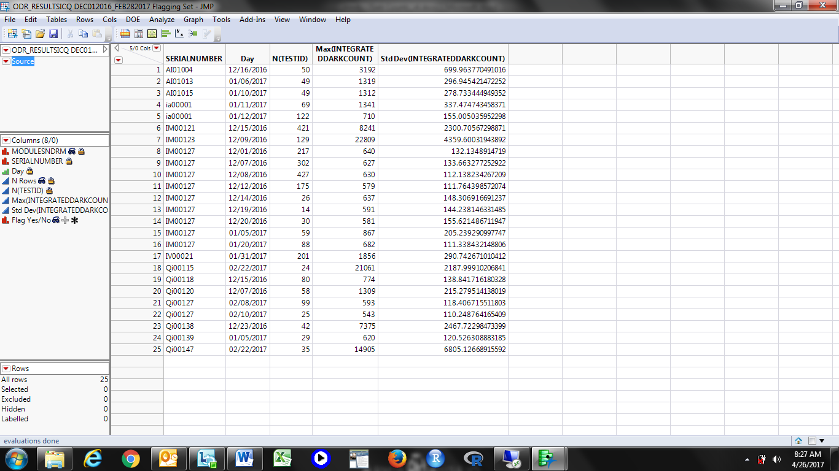

**PHM Specialist Analysis Output**

The following 25 instruments (SERIALNUMBER) were identified as violating the algorithm by the PHM Specialist:

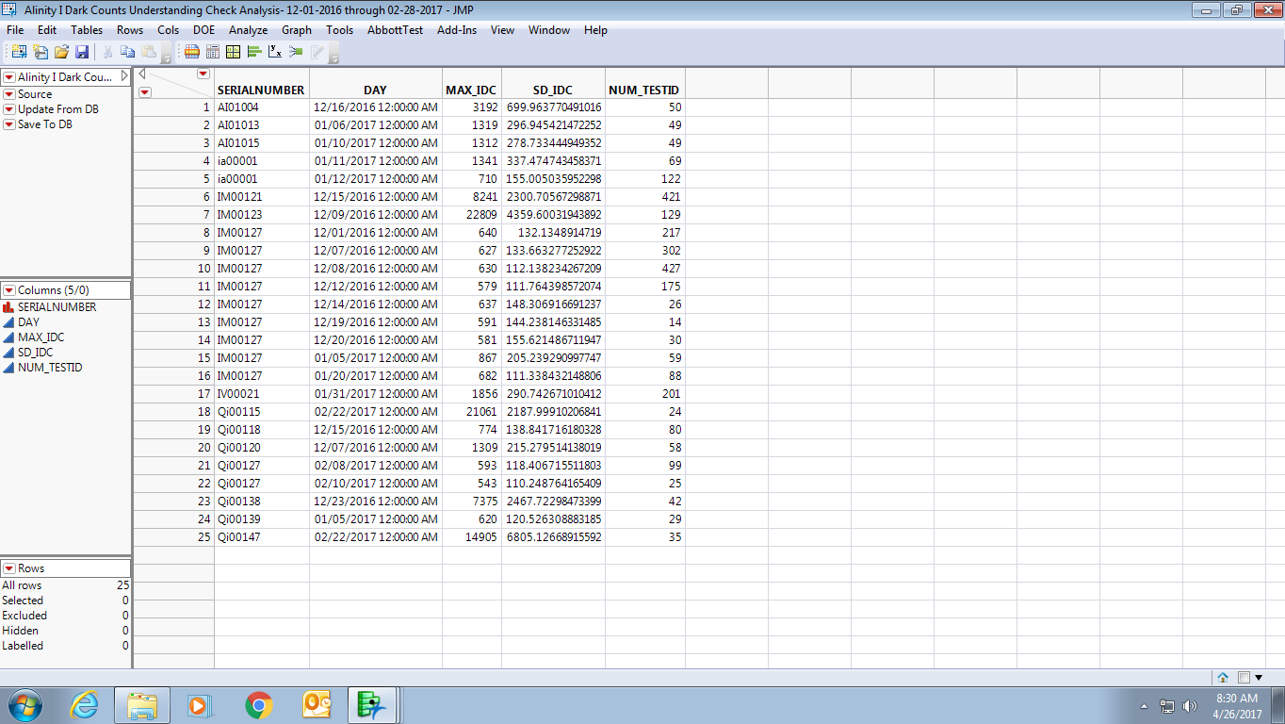

**Algorithm Developer & PHM Specialist Output Comparison**

|  |  |  |  |
| --- | --- | --- | --- |
| Total # of Unique Instrument-Days Tested | Total # of Algorithm Developer Flags | Total # of PHM Specialist Flags | Total # of Matched Flags (Algorithm Developer vs. PHM Specialist) |
| **2,679** | **25** | **25** | **25** |

**Understanding Check Summary**

Based on the outputs from both the Algorithm Developer and PHM Specialist, the PHM Specialist’s understanding of the delivered algorithm is confirmed. Both the Algorithm Developer and PHM Specialist analyzed the same data set and got the same results. In particular, the SERIALNUMBER and Day/DAY fields matched for all 25 instrument-day (SERIALNUMBER- Day/DAY) combinations. This means that both the Algorithm Developer and PHM Specialist flagged the same 25 algorithm violations within the given data set. Furthermore, there were no mismatches between the output from the Algorithm Developer and the output from the PHM Specialist.

**APPENDIX 3:** Algorithm Transition to Apollo – PHM Specialist to Apollo Developer

**Data Set Description**

The data set for this transition was retrieved from the IDAQOWNER.ICQ_RESULTS table within the DABBTO database. Data was collected for all available instruments between May, 21 2018 and May 23, 2018, inclusive.

**PHM Specialist Analysis Output**

The following instrument-day (MODULESN-TRUNC(EVALS.DAY)) was identified as violating the algorithm by the PHM Specialist:

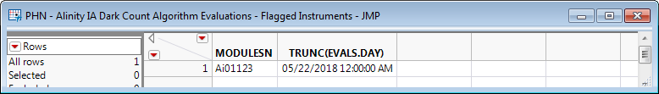

**Apollo Developer Analysis Output**

The following instrument-day (SN-FLAG_DATE) was identified as violating the algorithm by the Apollo Developer:

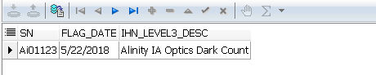

**Algorithm Transition Summary**

Based on the outputs from both the Apollo Developer and PHM Specialist, the Apollo Developer’s understanding of the delivered algorithm is confirmed. Both the Apollo Developer and PHM Specialist analyzed the same data set and got the same results. In particular, the MODULESN/SN and TRUNC(EVALS.DAY)/FLAG_DATE fields matched. This means that both the Apollo Developer and PHM Specialist flagged the same algorithm violation within the given data set.